X. Experimental Results

x.1 Result of Track Pedestrians

This project has basically achieved the detection and tracking of pedestrians, while in the evaluation of the results we have combined qualitative and quantitative analysis methods to evaluate our project. For the quantitative analysis, we mainly used indicators commonly used for binary classification, such as precious and recall.

TP (True Positive) prediction is a positive sample and the prediction is correct. The closer this metric is to the number of annotations of pedestrians in the validation set, the higher the detection rate of the detector.

FP (False Positive) predicts a positive sample but the prediction is wrong. This indicator reflects the false detection rate, the lower the false detection rate the better.

FN (False Negative) A negative prediction but an incorrect prediction, i.e. a sample that should have been detected was not detected.

Precious describes the proportion of TP in the test results and is calculated as Precious = TP/(TP+FP), the larger the indicator, the higher the detection accuracy.

Recall describes the detection rate of the marked pedestrians and is calculated as Recall = TP/(TP+FN).

Considering that the test file has 450 frames, the quantitative analysis was carried out only 3 times with random sampling, 10 frames each time for analysis, and the following results were obtained:

TABLE I. INDICATORS OF PEDESTRIANS DETECTION

|  |  |  |  |  |  |
| --- | --- | --- | --- | --- | --- |
|  | TP | FP | FN | precious | recall |
| 1 | 14.0 | 0.2 | 3.0 | 98.6% | 82.4% |
| 2 | 15.2 | 0.4 | 3.6 | 97.5% | 80.9% |
| 3 | 14.6 | 0.4 | 3.4 | 97.3% | 81.1% |
| mean | 14.6 | 0.3 | 3.3 | 97.8% | 81.5% |

From this it can be concluded that the pedestrian detection carried out in this project has a high degree of accuracy and the results obtained are reliable.

As for the qualitative part of the analysis, we have selected some representative types of error detection, and it can be seen that humanoid models are incorrectly detected as humanoid, in addition, it is often difficult to detect pedestrians whose features are not obvious due to their proximity to the background and their distance.

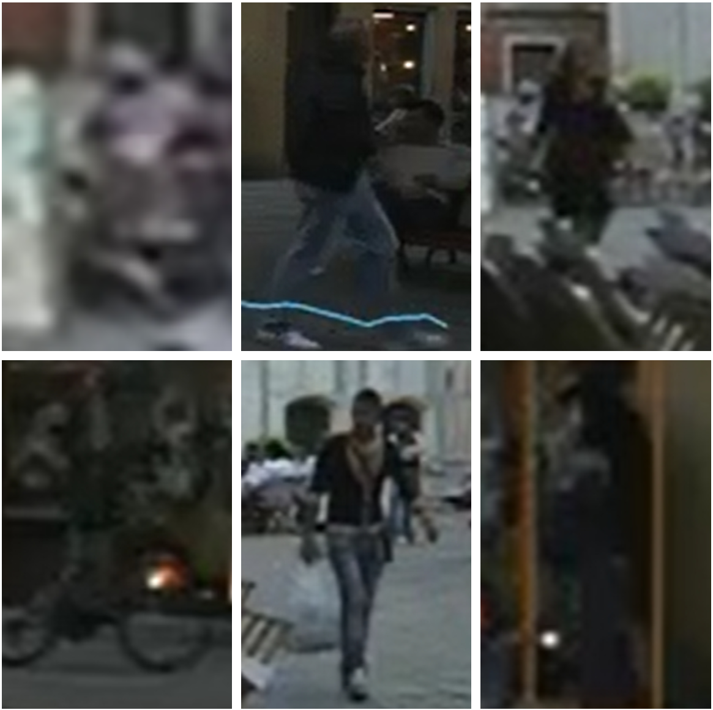

Fig. 1. Examples of detection errors or non-detection

Overall, task 1 was completed well, perhaps there is a better algorithm to optimize the detection results that we need to continue to learn and research.

x.2 Result of Count Pedestrians and Analyze Pedestrians

Task 2 and task 3 was equally well done. Based on the results of task 1, we show the counts and result of analysis at the bottom of the video as follows:

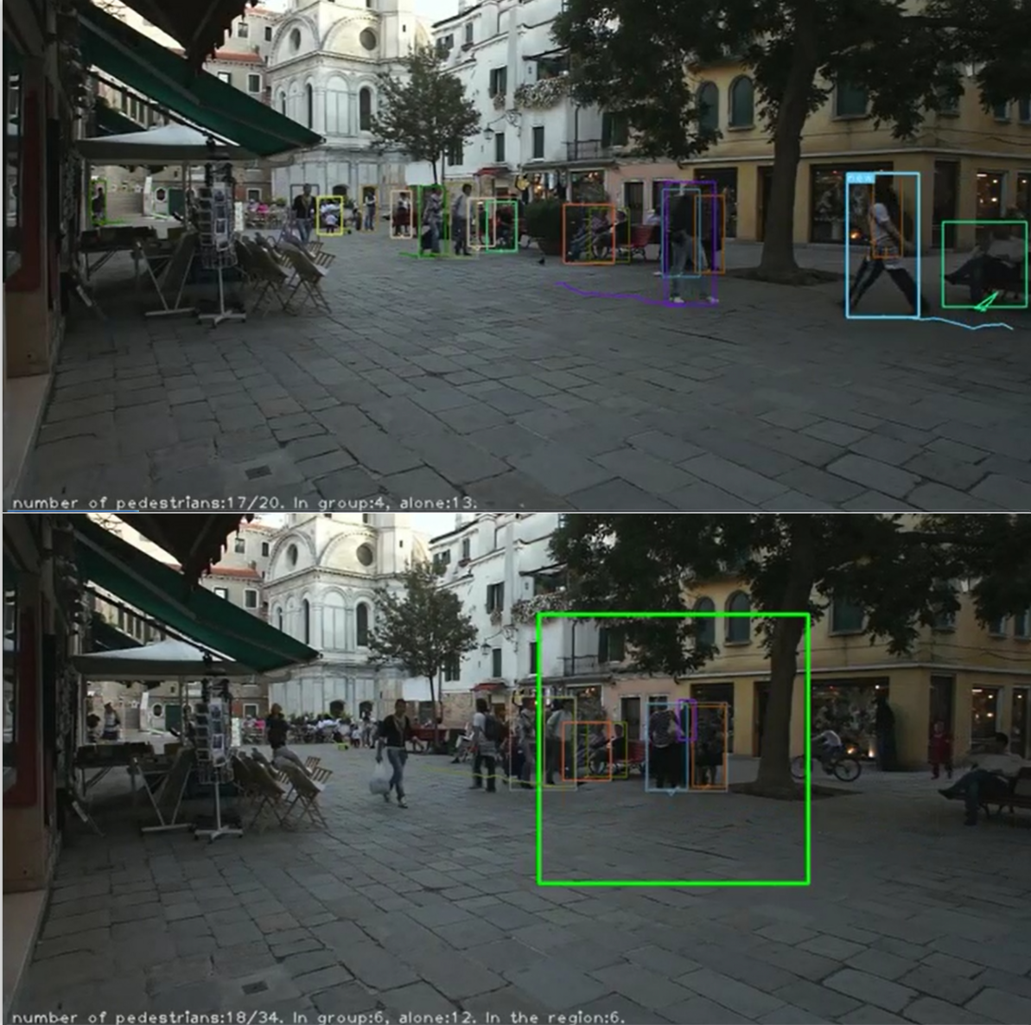

Fig.2. Examples of Pedestrian statistics analysis results

The results are presented in the form of ‘numbers of pedestrians: {a/b}. In group:{c}. alone: {d}. (In the region: {e})’.

For this form, a is denoted as the total count of pedestrians present in the current video frame while b represents the total count of all unique pedestrians detected since the start of the video. As for c and d, they represented how many pedestrians walk in groups and how many walk alone. e indicates the total number of pedestrians in the manually drawn rectangular box.

If the group forms, there will be a larger frame that will enclose all the pedestrians within the group, while the destruction of the group will cause the group frame to shrink or disappear. In addition, new pedestrians entering the video area will have a 'NEW' mark to the left of the detection box to indicate the situation.

It is clear that the results of all the requested statistical analyses are displayed below the video, and as long as the boxes in task 1 are drawn correctly, the results displayed are also correct.